Lab1 Zhuoyang Chen 08/30/2019

**Numerical integration of ODEs in Matlab**

**1. Simulating exponential decay**

In this example, we have $f\left(x\right)=\frac{dx}{dt}=-kx$

To use ode45, we need to define our differential equation as a function of $t$ and $x$.

Shown as following script:

**function** dxdt **=** exp_decay**(**t**,**x**)**

k **=** 2**;**

dxdt **=** **-**k**\***x**;**

**end**

Then we used the ode45 function as below to simulate the $f\left(x\right)$:

**[**t**,**x**]** **=** ode45**(@**exp_decay**,[**0 t_end**],**x0**,**options**);**

which exp_decay is the differential equation, **[**0 t_end**]** is the duration of the numerical integration, and x0 gives the initial value.

**Running the simulation**

The figure of output is shown as below with x0 = 10 and t_end = 5:

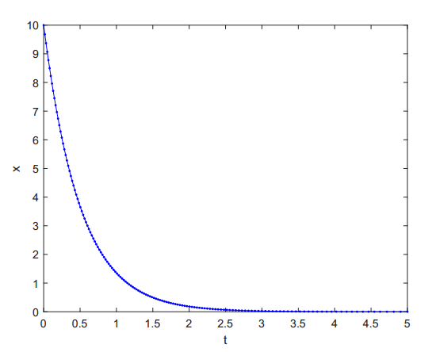

**Messing with the output**

We should notice that the stepsize $∆t$ vary during the simulation, which makes x values not evenly spaced. The changing $∆t$ is caused by the modification when the error of estimation approaching the value we set in options **=** odeset**(**'RelTol'**,**1e-8**)**, which is 1e-8.

So when the estimated error is larger than tolerance, $∆t$ will be decreased and used to do the ode45 again. This process will iterate until the error is less than the threshold tolerance.

The threshold we set guarantee the precision of the numerical integration, but we should realize that the more accurate we want to achieve, the more computational cost would be encounter. To compare the output figures with modified and the evenly spaced $∆t$, we generated a t vector just after we finished doing the first ode45, using

dt **=** t_end**/(**length**(**t**)-**1**);**

t_even **=** 0**:**dt**:**t_end**;**

And then pass the t_even vector into the ode45 function.

[t1,x1] = ode45(@exp_decay,t_even,x0,options);

The output figure was shown as below:

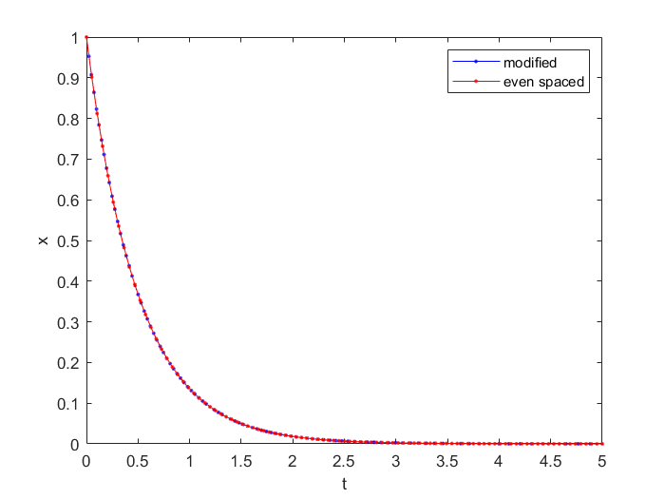

We can see that there is some difference because the tspans are differently chosen, but actually the two curves are quite similar. We did supposed that the integration using modified tspan would be more accurate than the evenly spaced one, but it wasn’t shown in this simulation.

**2. Simulating the lactose switch model**

The ODE here is $f\left(x\right)=\frac{a+x^{2}}{1+x^{2}}-kx$.

Define the ODE in Matlab as below:

**function** dxdt **=** exp**(**t**,**x**)**

a **=** 0.05**;**

k **=** 0.3**;**

dxdt **=** **(**a**+**x**.^**2**)./(**1**+**x**.^**2**)-**k**\***x**;**

**end**

**Implementation**

To begin with, we used an initial condition of $x0=0.5$, with tspan from 0 to 5:

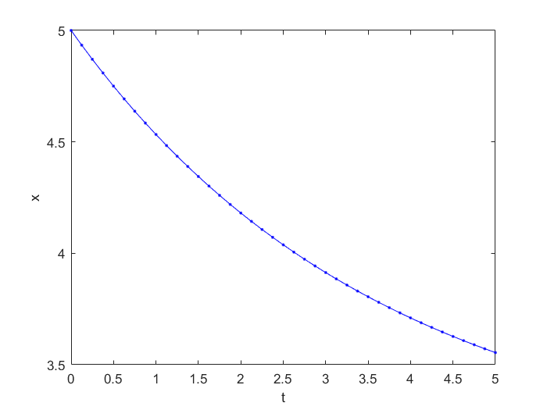

From the figure we found that at the end of the time span, $x(t)$ doesn’t reach a steady-state. So I increased the initial condition from 5 to 30, and then got:

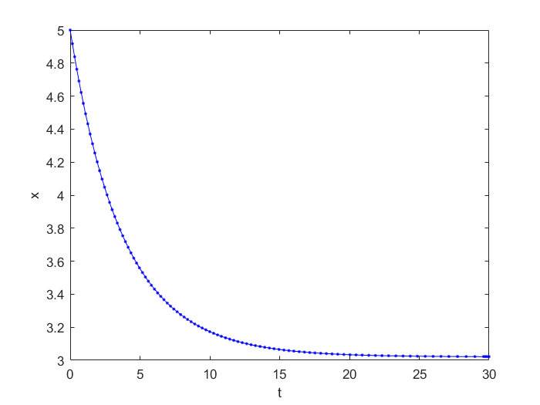

which eventually reach a steady-state at round 3.

**Effect of changing the initial condition**

I tried different initial conditions and I was convinced that there is only one stable fixed point. The figure of $x(t)$ is shown below:

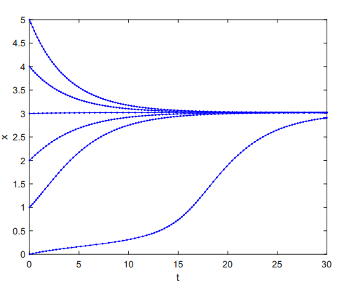

From below or above the fixed point near 3, $x(t)$ is approaching $x=3$.

**Investigation of model dynamics**

I increased k from 0.3 to 0.6, the figure is shown as below:

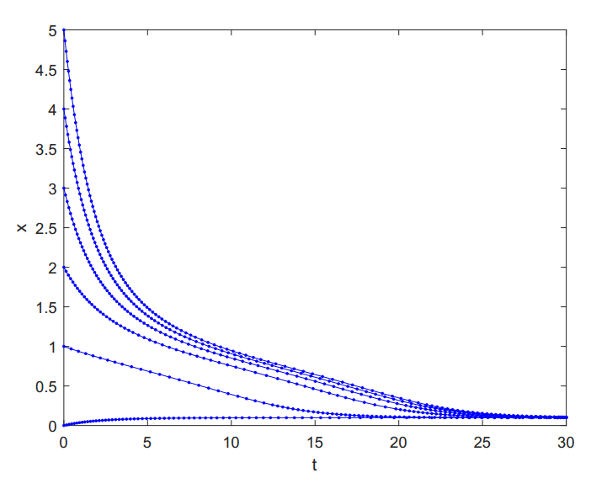

We can see from the graph that $x(t)$ with different initial values are approaching a line around $x=0.1$. There is only one fixed point near 0.1.

**Bistability**

We can plot the two components separately but in one figure to see how different values of k could affect the stability of fixed points. We simulated with k=0.4, 0.5, 0.6. Figure is shown as below:

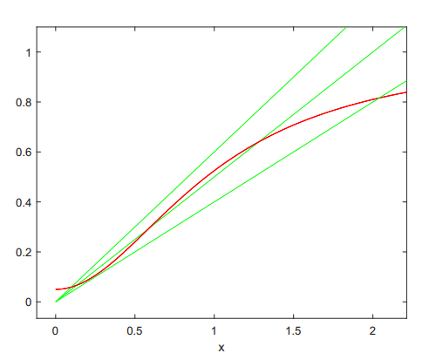

We could see that if k is too large or too small, there would be just one stable fixed point, while with a proper k, there would be three fixed point with the middle one unstable. From the figure, we knew that when k =5, $h(x)=kx$ (green) and $g(x)=\frac{a+x^{2}}{1+x^{2}}$ (red) have three intersection points, indicating that there is bistatbility. From Matlab interaction panel, we could tell that the two stable fixed points are near 0.13, 1.28, and the instable fixed point is near 0.59.

I then used the k value above to simulate $f(x)$, which equals to $g(x)-h(x)$. The figure is shown as below:

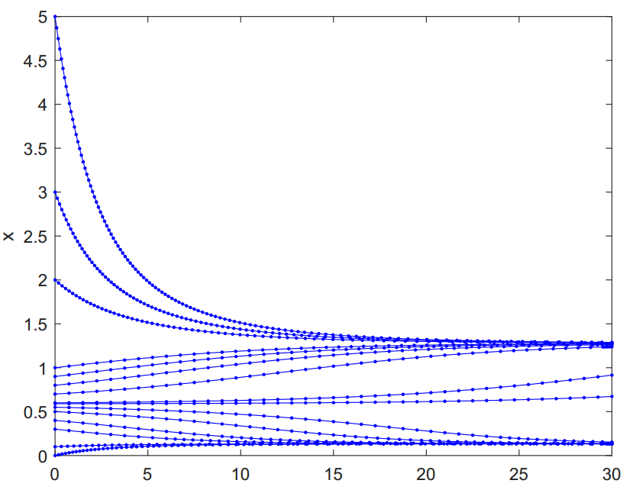

which shows that there are two stable fixed points.

Modified different values of k, and found that $f(x)$ would only have one stable fixed point when k is less than near 0.42 or larger than near 0.53, when x equals to 0.25 and 0.89 respectively.

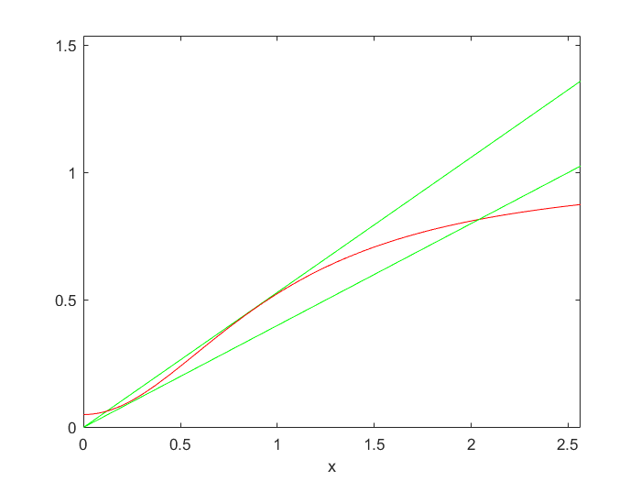

From the figure, we knew that $x0$ that separated the basin of attraction flank the unstable fixed point, if exists, and be flanked by the two sable fixed points.

**Bifurcation**

Let $f\left(x\right)= g\left(x\right)-h\left(x\right)= \frac{0.05+x^{2}}{1+x^{2}}-kx=0$, we have $k=\frac{0.05+x^{2}}{1+x^{2}}/x$

Use Matlab to plot the x-k curve, and got the output figure as below:

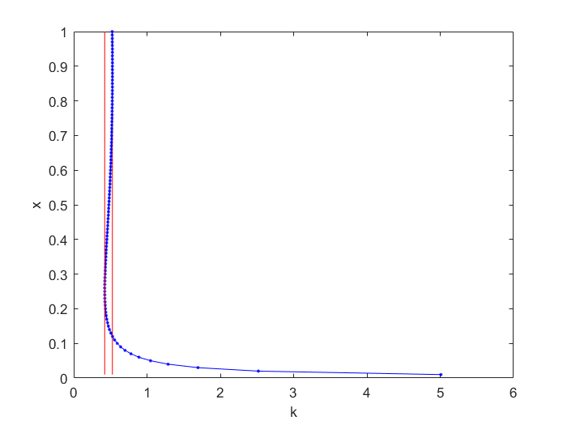

We can figure out the two saddle nodes from the x-k curve with coordinate (k, x):

(0.42393, 0.25) and (0.52797, 0.89).